|  |  |
| --- | --- |
| *Pacific Gas and Electric Company* | |
| Patch 7.6.6 Installation Guide | |
|  |  |
|  |  |
| Project | ED AM/GIS |
|  |  |
| Prepared by | Ashish Narasimham |
| Date | 9/20/2013 |
| Version | 1.1 |
| Version Type | Final |

|  |  |  |  |
| --- | --- | --- | --- |
| Revision History | | | |
| Document # | Date | Author | Summary of Changes |
| 1.0 | 9/18/13 | Ashish Narasimham | Initial Document Creation |
| 1.1 | 9/20/13 | Ashish Narasimham | Substation fixes for 2 offsets and 1 expression |

# Introduction

## Purpose

This document is intended to detail the implementation and configuration steps required to implement Patch 7.6.6 Installation Guide. This document describes the various configuration aspects required to complete any manual or automatic patch associated with this release. Each section in this document contains the steps required to patch the system in production.

## Terms Used

|  |  |
| --- | --- |
| OOTB | Out of the box. Unmodified from the commercial version. |
| TFS | Team Foundation Server |

## External Documents

Referenced are any external configuration documents or exports. These are documents that contain more detailed information about configuring a system or documents that can be loaded into an application to perform the configuration detailed in this document.

1. Python Script
   1. File location: \\sfetgis-nas01\sfgispoc_data\ApplicationDevelopment\IBM_Delivery\Production Release 6\Data Model
   2. File name: 01_Add_CUSTOMEROWNEDINDICATOR_to_SubStation_Tables.py
   3. File name: 02_Assign_Default_Value_To_CustomerOwnedIndicator_MultipleClasses.py
2. Connectivity Rules XML
   1. File location: \\sfetgis-nas01\sfgispoc_data\ApplicationDevelopment\IBM_Delivery\Production Release 6\Data Model
   2. File name: 7_6_6_connectivity_rules.xml

## List Of Fixes

Below is the list of change requests detailing all fixes for the data model for this release:

|  |  |  |  |
| --- | --- | --- | --- |
| **Item Number** | | **Title** | **Work Item Type** |
| [9999](http://edappgistfsprd1:8080/tfs/ElectricDistCollection/EDAMGIS/_workItems#_a=edit&newQuery=true&id=9999) | | Data Model 7.6.6 | Change Request |
| [9661](http://edappgistfsprd1:8080/tfs/ElectricDistCollection/EDAMGIS/_workItems#_a=edit&newQuery=true&id=9661) | PAR 27206: Create Field CustomerOwnedIdc on Feature Classes | Change Request |
| [9708](http://edappgistfsprd1:8080/tfs/ElectricDistCollection/EDAMGIS/_workItems#_a=edit&newQuery=true&id=9708) | Change Multiple Substation Annotation Feature Classes | Change Request |
| [10051](http://edappgistfsprd1:8080/tfs/ElectricDistCollection/EDAMGIS/_workItems#_a=edit&newQuery=true&id=10051) | Remove Carriage Return from field alias SUBStationTransformer for HighSideConfiguration | Change Request |
| [10047](http://edappgistfsprd1:8080/tfs/ElectricDistCollection/EDAMGIS/_workItems#_a=edit&newQuery=true&id=10047) | Remove Carraige Return from field alias SUBMTU for SubmerciblIdc | Change Request |
| [10070](http://edappgistfsprd1:8080/tfs/ElectricDistCollection/EDAMGIS/_workItems#_a=edit&newQuery=true&id=10070) | "SUB Transformer Config" domain addition. | Change Request |
| [10049](http://edappgistfsprd1:8080/tfs/ElectricDistCollection/EDAMGIS/_workItems#_a=edit&newQuery=true&id=10049) | SUBGeneratorAnno Annotation Expression | Change Request |
| [10050](http://edappgistfsprd1:8080/tfs/ElectricDistCollection/EDAMGIS/_workItems#_a=edit&newQuery=true&id=10050) | Bug 9829: Delete Relationship Between Conduit System and Subsurface Structure | Change Request |
| [10054](http://edappgistfsprd1:8080/tfs/ElectricDistCollection/EDAMGIS/_workItems#_a=edit&newQuery=true&id=10054) | Connectivity Rules Update | Change Request |
| [10046](http://edappgistfsprd1:8080/tfs/ElectricDistCollection/EDAMGIS/_workItems#_a=edit&newQuery=true&id=10046) | Remove Carraige Return from field alias SUBINTERUPTINGDEVICE for InterruptingMedium and GasGapShuntTripIdc | Change Request |
| [10073](http://edappgistfsprd1:8080/tfs/ElectricDistCollection/EDAMGIS/_workItems#_a=edit&newQuery=true&id=10073) | Substation Generator GlobalID Must Be a GlobalID Type | Change Request |

## Summary of Steps to Complete Patch

These are the high-level steps to complete the installation and configuration of the data model patch. Use this table as a guide for completing the installation. Links are provided that can lead either within the document for detailed explanations or to external sites such as Sharepoint.

|  |  |  |  |
| --- | --- | --- | --- |
|  | **Step Name** | **Description** | **CR (if applicable)** |
|  | Open a Database Connection | Open a database connection in ArcCatalog | - |
|  | PAR 27206: Create Field CustomerOwnedIdc on Feature Classes | Run a Python script to create the CustomerOwnedIDC field on substation feature classes | [9661](http://edappgistfsprd1:8080/tfs/ElectricDistCollection/EDAMGIS/_workItems#_a=edit&newQuery=true&id=9661) |
|  | Change Multiple Substation Annotation Feature Classes | Change annotation for multiple substation feature classes | [9708](http://edappgistfsprd1:8080/tfs/ElectricDistCollection/EDAMGIS/_workItems#_a=edit&newQuery=true&id=9708) |
|  | Remove Carriage Return from field alias SUBStationTransformer for HighSideConfiguration | Delete a carriage return from the alias for a field | [10051](http://edappgistfsprd1:8080/tfs/ElectricDistCollection/EDAMGIS/_workItems#_a=edit&newQuery=true&id=10051) |
|  | Remove Carraige Return from field alias SUBMTU for SubmerciblIdc | Delete a carriage return from the alias for a field | [10047](http://edappgistfsprd1:8080/tfs/ElectricDistCollection/EDAMGIS/_workItems#_a=edit&newQuery=true&id=10047) |
|  | ["SUB Transformer Config" domain addition.](#_"SUB_Transformer_Config" ) | Add a domain/value to a substation domain | [10070](http://edappgistfsprd1:8080/tfs/ElectricDistCollection/EDAMGIS/_workItems#_a=edit&newQuery=true&id=10070) |
|  | SUBGeneratorAnno Annotation Expression | Add an annotation expression to the SUBGeneratorAnno feature class | [10049](http://edappgistfsprd1:8080/tfs/ElectricDistCollection/EDAMGIS/_workItems#_a=edit&newQuery=true&id=10049) |
|  | Bug 9829: Delete Relationship Between Conduit System and Subsurface Structure | Delete the relationship between Conduit System and Subsurface structure to allow disconnects on Conduit | [10050](http://edappgistfsprd1:8080/tfs/ElectricDistCollection/EDAMGIS/_workItems#_a=edit&newQuery=true&id=10050) |
|  | Connectivity Rules Update | Import connectivity rules into db | [10054](http://edappgistfsprd1:8080/tfs/ElectricDistCollection/EDAMGIS/_workItems#_a=edit&newQuery=true&id=10054) |
|  | Remove Carraige Return from field alias SUBINTERUPTINGDEVICE for InterruptingMedium and GasGapShuntTripIdc | Remove carriage return from feature class’s field | [10046](http://edappgistfsprd1:8080/tfs/ElectricDistCollection/EDAMGIS/_workItems#_a=edit&newQuery=true&id=10046) |
|  | Substation Generator GlobalID Must Be a GlobalID Type |  | [10073](http://edappgistfsprd1:8080/tfs/ElectricDistCollection/EDAMGIS/_workItems#_a=edit&newQuery=true&id=10073) |
|  | Update Data Model Version Table | Update the data model version table to reflect this update | - |

# Open a Database Connection in ArcCatalog

1. Open ArcCatalog.
2. Within the Catalog Tree, expand “Database Connections” and open the active connection for this process. This is the connection that is referenced in the change request associated with this document (EDGIS<DB name in the format X#Y> )

# PAR 27206: Create Field CustomerOwnedIdc on Feature Classes

1. Open the folder for the Python script referenced in the External Documents section through Windows Explorer.
2. Open each script and set the database to the target SDE database.
3. Run both scripts
   1. by double clicking each one and waiting for it to finish before moving onto the next one.

# Change Multiple Substation Annotation Feature Classes

1. Open the SubstationDataset

## Open the SubBusbarAnno feature class properties

1. Change the size for all annotation classes from 5.5 to 5.
   1. Select the annotation class
   2. In the text symbol area, change the font size from 5.5 to 5.  
      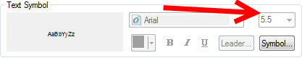
2. Change BusBarUsage expression:

Function FindLabel ( [BUSBARUSAGE], [BUSNUMBER] )

if isnull([BUSBARUSAGE]) then

if isnull([BUSNUMBER]) then

else

FindLabel = "NO." & [BUSNUMBER]

end if

else

FindLabel = [BUSBARUSAGE]

end if

End Function

1. Remove BusNumber subclass
   1. Select the BusNumber annotation class and click 
2. Select the Default annotation class, Symbol (in the Text Symbol section), then Edit Symbol.
3. Set Default Y Offset: 13

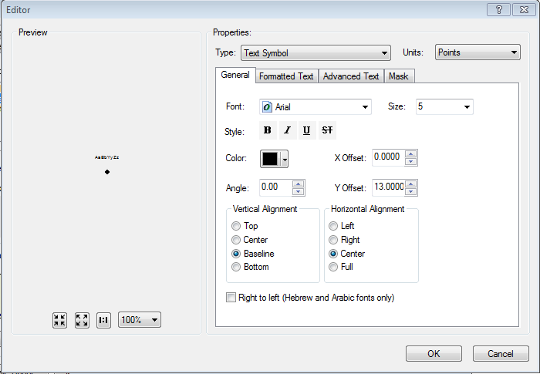

1. Press OK and OK again to accept changes.
2. Select the Section annotation class, Symbol, and Edit Symbol.
3. Set Section Y Offset: 7

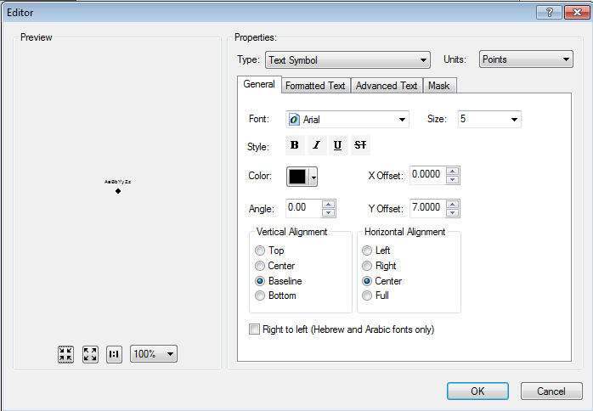

1. Press OK and OK again to accept changes.
2. Select the BusBarUsage annotation class, Symbol, and Edit Symbol.
3. Set BusBarUsage Y Offset: 1

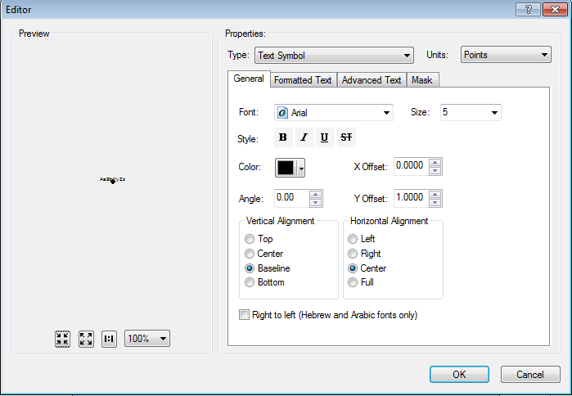

## Open the EDGIS.SUBCapacitorBankAnno feature class properties

1. Change Default annotation subclass size = 5

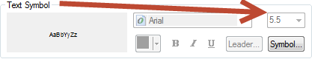

1. change Default annotation expression:

Function FindLabel ( [OPERATINGNUMBER], [OPERATINGNUMBER2] , [TOTALKVAR] )

mystring = ""

myopnum = [OPERATINGNUMBER] & vbCrLf

myopnum2 = [OPERATINGNUMBER2] & vbCrLf

myKVAR = ""

if isnull([TOTALKVAR]) then

else

myKVAR = [TOTALKVAR] & " KVAR"

end if

mystring = myopnum & myopnum2 & myKVAR

FindLabel = mystring

End Function

1. Set offset = 10

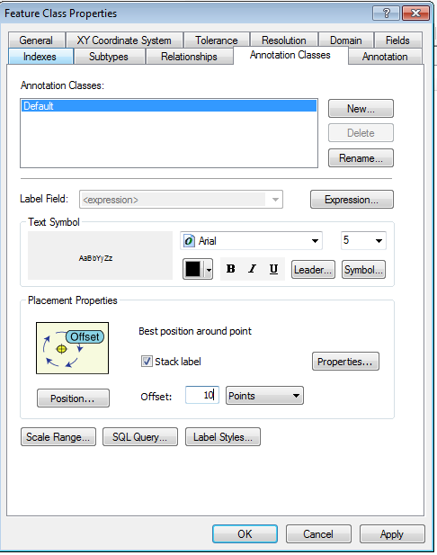

## Open the EDGIS.SUBCurrentTransformerAnno feature class properties

1. Change Default annotation subclass size = 5  
   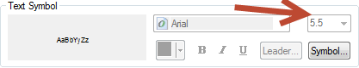
2. Set offset = 3  
   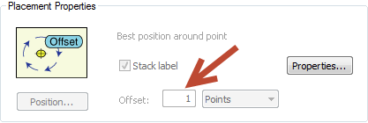

## Open the EDGIS.SUBFuseAnno feature class properties

1. Change Default annotation subclass size = 5.
2. Select Symbol then Edit Symbol. Set Y offset = 10.

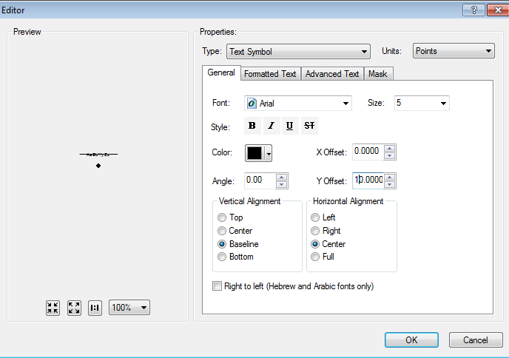

## EDGIS.SUBInterruptingDeviceAnno

1. Select the Subclass Operating-1 Line annotation class.
2. Navigate to Symbol and then Edit Symbol.
3. Select the Advanced Text tab and select Properties under Text Background.  
   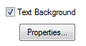
4. Select Symbol on the following screen:  
   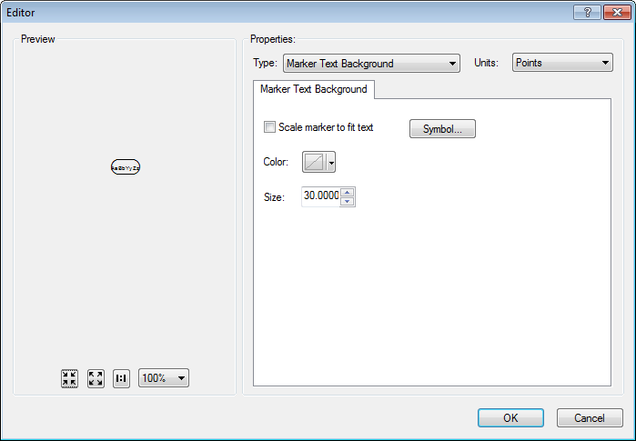
5. Select Edit Symbol.
6. Set the “rounded rectangle” background symbol to match the following image.
7. Delete the “line” symbol in the bottom left box. Match the

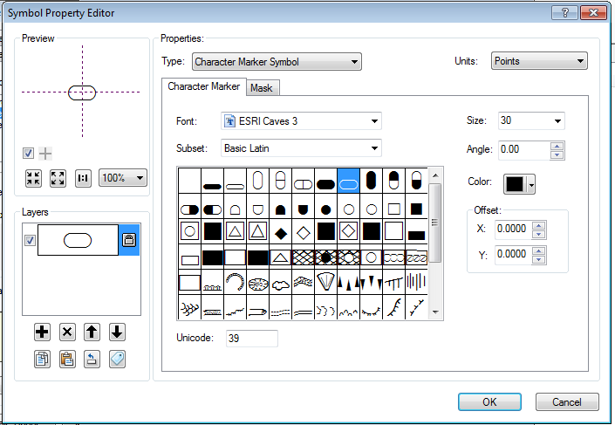

1. Select the Operating-1 Line annotation class and select Symbol->Edit Symbol.
2. Set Y Offset = 28

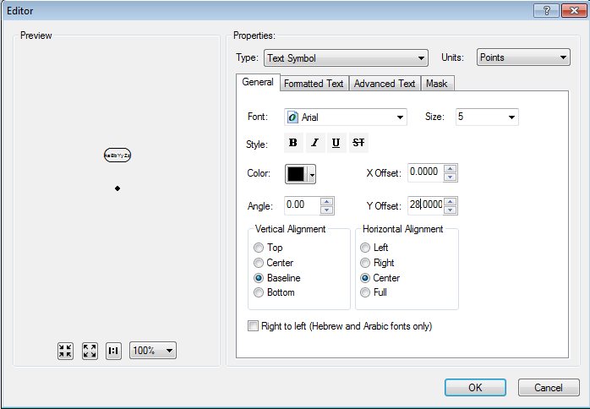

1. Set font size = 5 under Text Symbol.

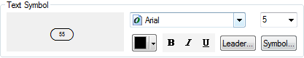

1. Change Operating-1 Line expression to:

Function FindLabel ( [OPERATINGNUMBER], [OPERATINGNUMBER2], [NORMALPOSITION_A], [NORMALPOSITION_B], [NORMALPOSITION_C] )

if isnull([OPERATINGNUMBER2]) and not isnull([OPERATINGNUMBER]) then

if [NORMALPOSITION_A] = "Open" OR [NORMALPOSITION_B] = "Open" OR [NORMALPOSITION_C] = "Open" then

FindLabel = "<CLR green='125'> " & [OPERATINGNUMBER] & " </CLR>"

else

FindLabel = [OPERATINGNUMBER]

end if

end if

End Function

1. Select the Operating-2 Line annotation class.
2. Navigate to Symbol and then Edit Symbol.
3. Select the Advanced Text tab and select Properties under Text Background.  
   
4. Select Symbol on the following screen:  
   
5. Select Edit Symbol.
6. Set background symbol as below image:

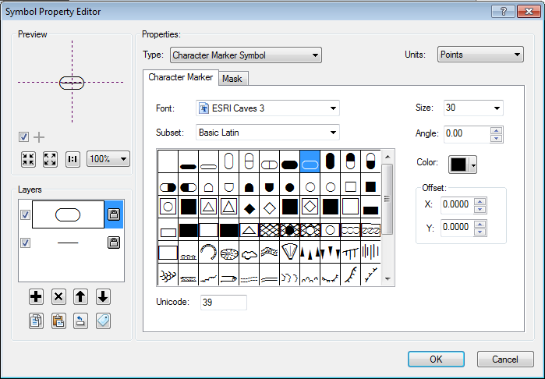

1. Select Symbol->Edit Symbol and change the Y offset to 23

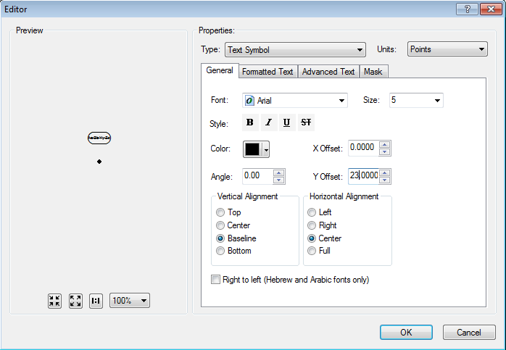

1. set font size = 5 under Text Symbol.

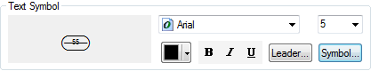

1. Change Operating-2 Line expression to:

Function FindLabel ( [OPERATINGNUMBER], [OPERATINGNUMBER2], [NORMALPOSITION_A], [NORMALPOSITION_B], [NORMALPOSITION_C] )

if not isnull([OPERATINGNUMBER2]) and not isnull([OPERATINGNUMBER]) then

if [NORMALPOSITION_A] = "Open" OR [NORMALPOSITION_B] = "Open" OR [NORMALPOSITION_C] = "Open" then

FindLabel = "<CLR green='125'> " & [OPERATINGNUMBER] & vbcrlf & [OPERATINGNUMBER2] & " </CLR>"

else

FindLabel = [OPERATINGNUMBER] & vbcrlf & [OPERATINGNUMBER2]

end if

end if

End Function

1. Select the Current annotation class and set size = 5

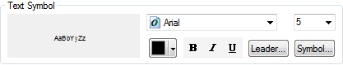

1. Select Symbol->Edit Symbol and change Y offset = 10

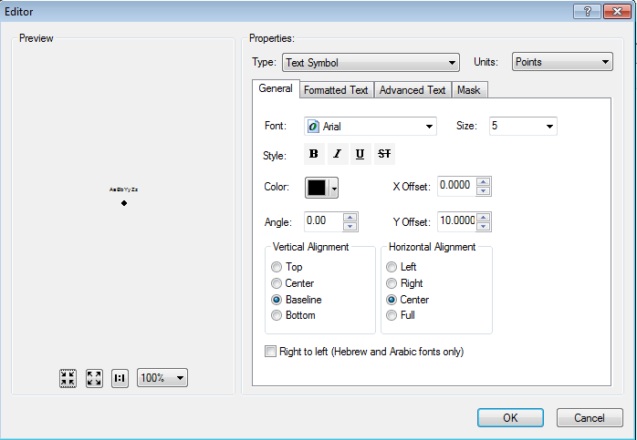

## EDGIS.SUBMtuAnno

1. Set all subclass sizes to 5 (Default, Operating-1 Line, and Operating-2 Line)  
   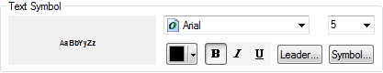
2. Select the Default annotation class. Change the expression to:

Function FindLabel ( [NUMBEROFUNITS], [PHASEDESIGNATION], [RATEDKVA], [HIGHSIDEVOLTAGE], [LOWSIDELNVOLTAGE], [LOWSIDELLVOLTAGE])

currenttext = ""

nextline = ""

mydash = ""

myratedkva = CStr([RATEDKVA] & "")

myNumUnits = CStr([NUMBEROFUNITS] & "")

myHSVolt = CStr([HIGHSIDEVOLTAGE] & "")

myLSLLVolt = CStr([LOWSIDELLVOLTAGE] & "")

myLSLNVolt = CStr([LOWSIDELNVOLTAGE] & "")

myVolt = ""

myPhaseDesg = CStr(Len([PhaseDesignation] & ""))

If myNumUnits = "1" and myPhaseDesg = "3" then

myPhase = "3P"

else

myPhase = "1P"

end if

if len(myNumUnits) > 0 and len(myphase) > 0 then

mydash = " - "

end if

nextline = myNumUnits & mydash & myphase

if len(myratedkva) > 0 then

if len(nextline) > 0 then

nextline = nextline & ", "

end if

nextline = nextline & myratedkva & " KVA"

end if

currenttext = nextline

nextline = ""

if len(myHSVolt) > 0 then

if len(currenttext) > 0 then

currenttext = currenttext & vbCrLf

end if

currenttext = currenttext & "HV:" & myHSVolt & " KV "

end if

if len(myLSLLVolt) > 0 then

nextline = "LV:" & myLSLLVolt & " V"

if len(myLSLNVolt) > 0 then

nextline = nextline & " / "

end if

end if

if len(myLSLNVolt) > 0 then

nextline = nextline & myLSLNVolt & " V"

end if

if len(nextline) > 0 then

if len(currenttext) > 0 then

currenttext = currenttext & vbCrLf

end if

currenttext = currenttext & nextline

end if

FindLabel = currenttext

End Function

1. Select Default annotation class.
2. Select Symbol->Edit Symbol and set Y offset = 7

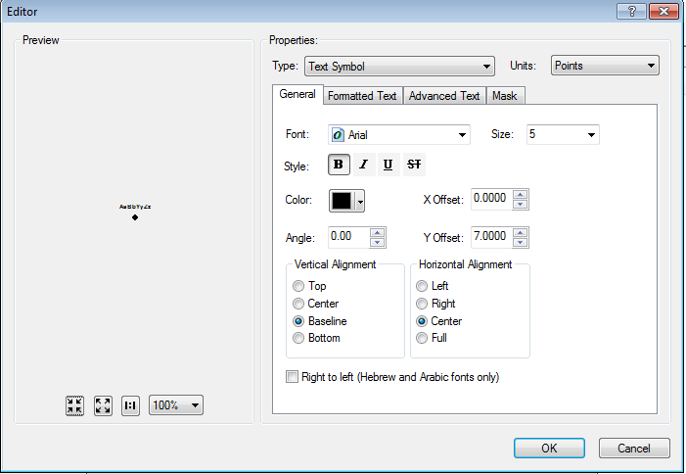

1. Uncheck the ‘Stack label’ checkbox.

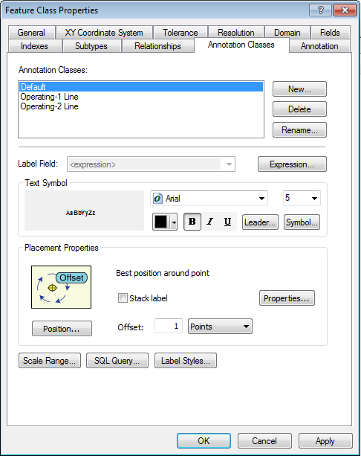

1. Select the Operating-1 Line annotation class.
2. Uncheck Operating-1 Line “Stack label”

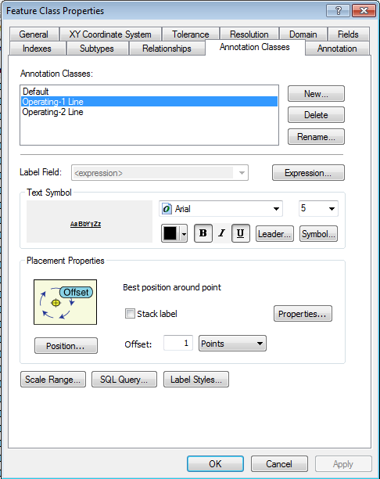

1. Click Symbol->Edit Symbol.
2. Set the Y offset = 25

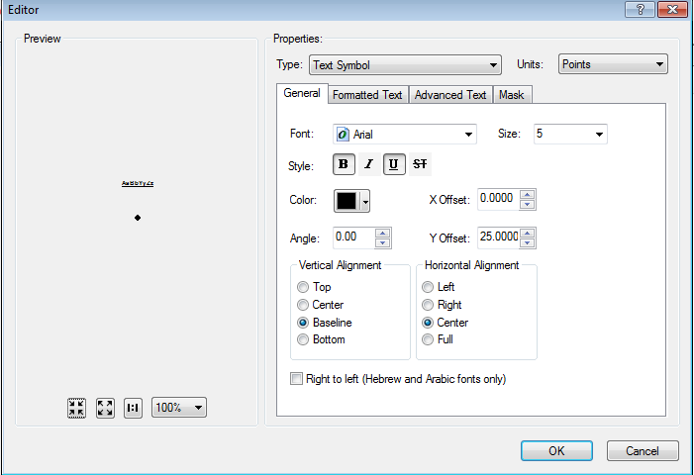

1. Select the Operating-2 Line annotation class. Uncheck “Stack Label”

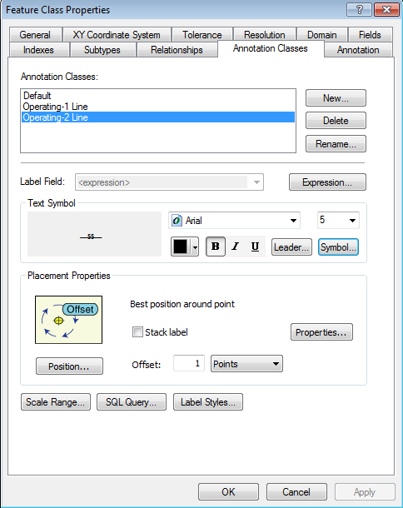

1. Select Symbol->Edit Symbol and change the Y offset to 30

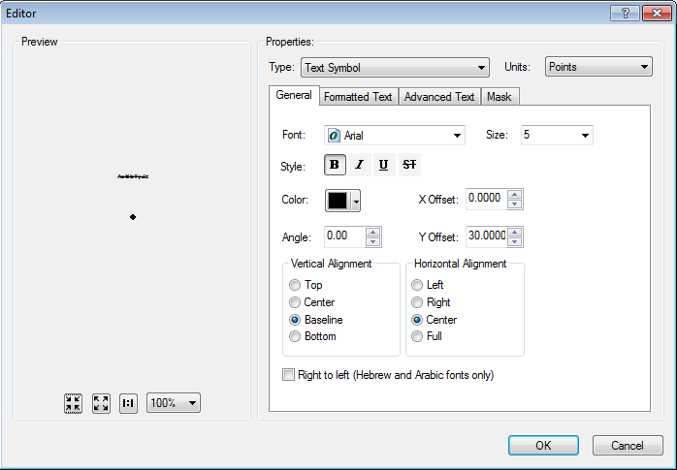

## EDGIS.SUBOHConductorAnno

1. Select the Default annotation class and set the size = 5

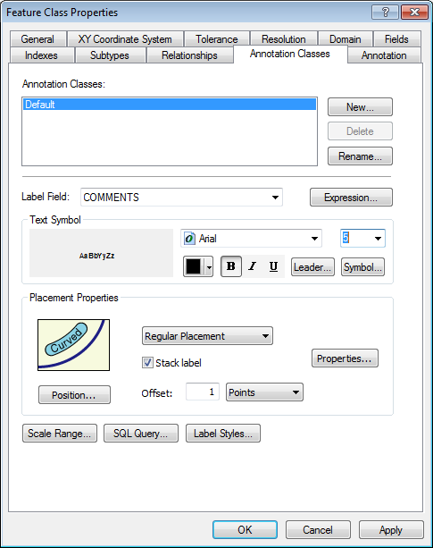

## EDGIS.SUBUGConductorAnno

1. Set Default size = 5

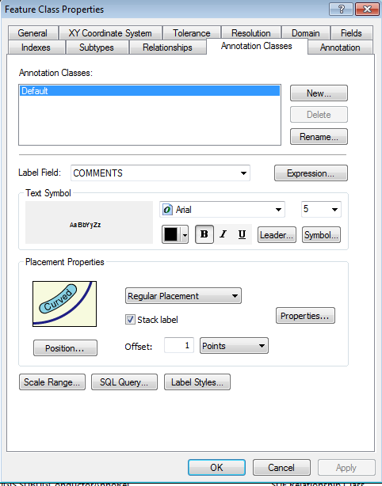

## SUBPotentialTransformerAnno

1. Set all annotation subclasses size = 5  
   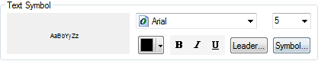
2. Select the Default annotation class.Uncheck “Stack Label”.

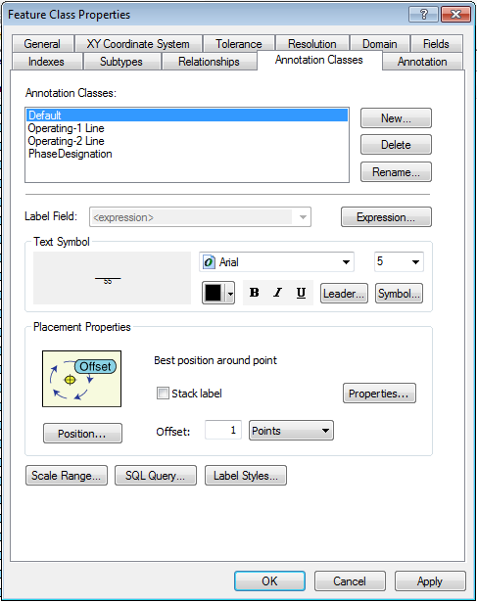

1. Change Default annotation subclass expression to:

Function FindLabel ( [NUMBEROFUNITS],[CONNECTEDRATIO], [PHASEDESIGNATION] )

myphase = ""

unitline = ""

myunits = CStr([NUMBEROFUNITS] & "")

myPhaseDesg = CStr(Len([PhaseDesignation] & ""))

If myunits = "1" and myPhaseDesg = "3" then

myPhase = "3P"

else

myPhase = "1P"

end if

if len(myunits)>0 AND len(myphase)>0 then

unitline = myunits & " - " & myphase

else

unitline = myunits & myphase

end if

FindLabel = "<UND> " & "PT " & "</UND>" & vbCrLf & unitline & vbCrLf & CStr([CONNECTEDRATIO] & " ")

End Function

1. Select Symbol->Edit Symbol and click the Advanced Text tab. Uncheck “Text Background”

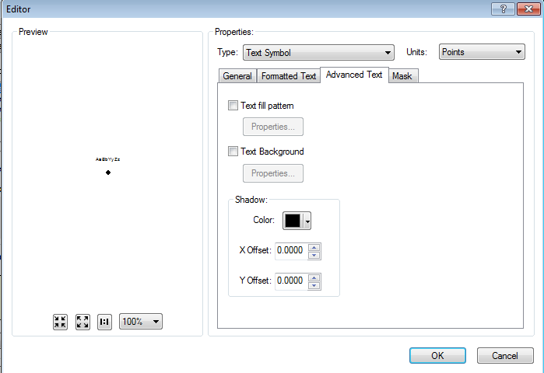

1. Select Symbol->Edit Symbol and set Y offset = 11

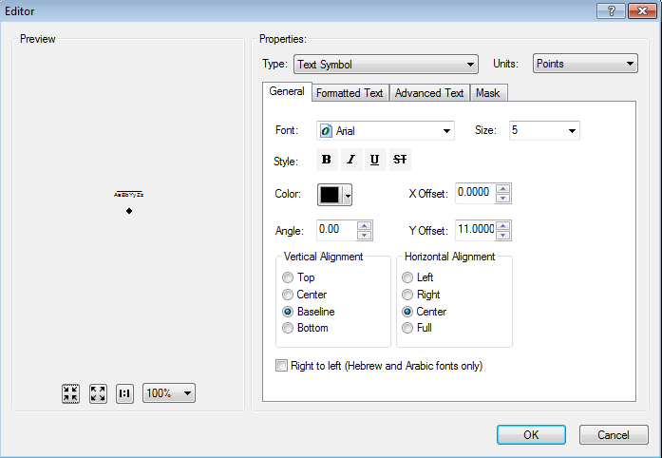

1. Select the Operating 1- Line annotation class. Uncheck “Stack Label”

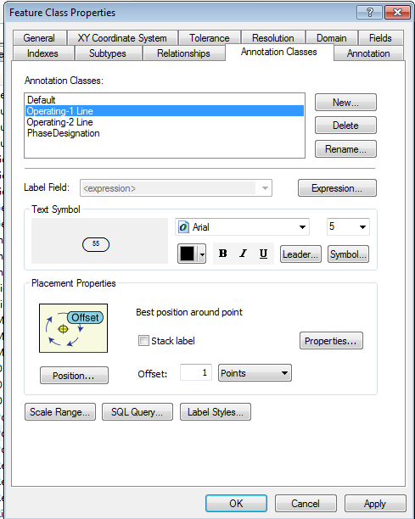

1. Navigate to Symbol and then Edit Symbol.
2. Select the Advanced Text tab and select Properties under Text Background.  
   
3. Select Symbol on the following screen:  
   
4. Select Edit Symbol.
5. Set the “rounded rectangle” background symbol to match the following image.
6. Delete the “line” symbol in the bottom left box.

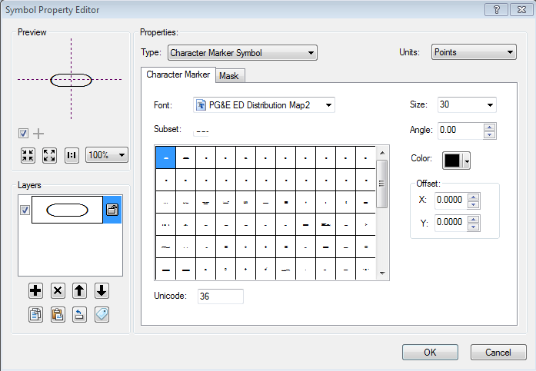

1. Select Symbol->Edit Symbol and set the Y offset = 32.

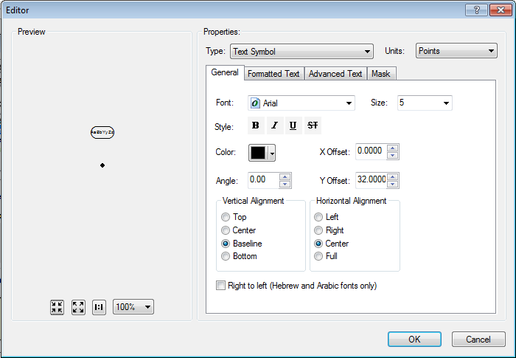

1. Select the Operating-2 Line annotation class. Uncheck “Stack Label”

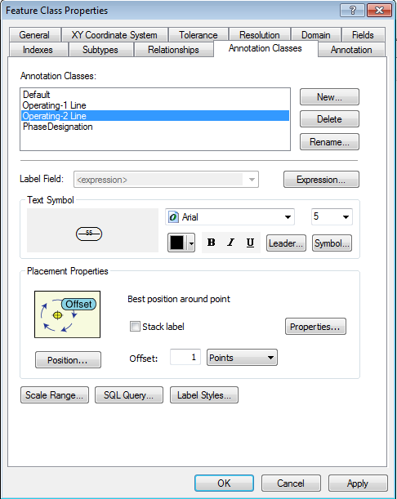

1. Navigate to Symbol and then Edit Symbol.
2. Select the Advanced Text tab and select Properties under Text Background.  
   
3. Select Symbol on the following screen:  
   
4. Select Edit Symbol.
5. Set the “rounded rectangle” background symbol to match the following image.
6. Delete the “line” symbol in the bottom left box.



1. Select Symbol->Edit Symbol and set the Y offset = 32.

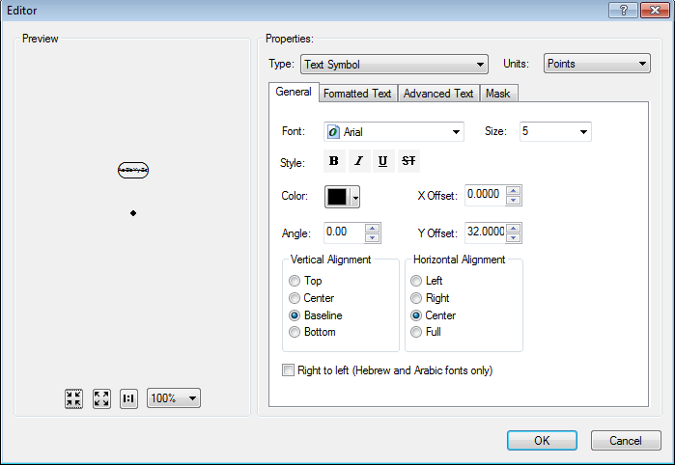

1. Change the Operating-2 Line expression to:

Function FindLabel ( [OPERATINGNUMBER], [OPERATINGNUMBER2] )

if len([OPERATINGNUMBER2]) > 0 then

FindLabel = "<UND> " & [OPERATINGNUMBER] & "</UND>" & vbCrLf & [OPERATINGNUMBER2]

end if

End Function

1. Select the Phasesdesignation annotation class.
2. Select Symbol->Edit Symbol.
3. Set the Y offset = 5.

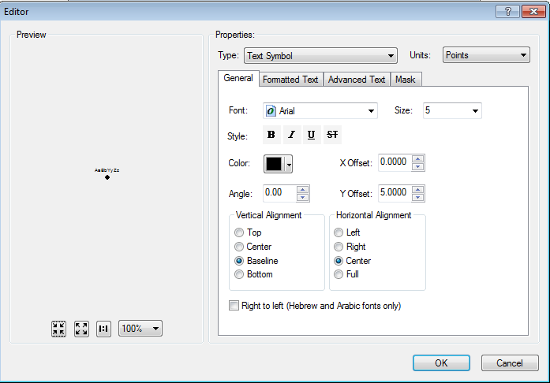

1. Uncheck PhaseDesignation “Stack Label”



## SUBReactorAnno

1. Change default subclass size = 5  
   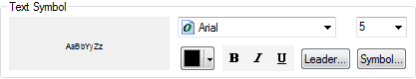
2. Change expression to:

Function FindLabel ( [PHASEDESIGNATION], [REACTANCEOHMS], [CCRATING], [INDUCTANCEMH] )

myphase = [PHASEDESIGNATION]

myline3 = ""

if not isnull([REACTANCEOHMS]) then

myline3 = [REACTANCEOHMS] & " 0"

if not isnull([INDUCTANCEMH]) then

myline3 = myline3 & vbCrLf & [INDUCTANCEMH] & " mH"

end if

else

if not isnull([INDUCTANCEMH]) then

myline3 = [INDUCTANCEMH] & " mH"

end if

end if

if not isnull([CCRATING]) then

FindLabel = myphase & vbCrLf & [CCRATING] & vbCrLf & myline3

else

FindLabel = myphase & vbCrLf & myline3

end if

End Function

1. Change the offset for the Default annotation class to 5 points.  
   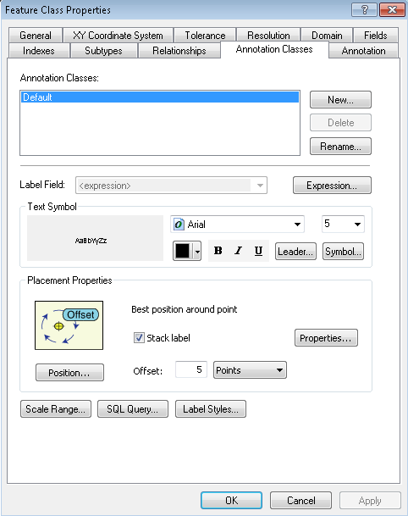

## SUBStationTransformerAnno

1. Change all annotation classes to size 5 (Default, Operating-1 Line, Operating-2 Line)  
   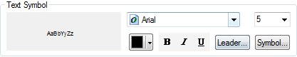
2. Uncheck all annotation class “Stack Label” (Default, Operating-1 Line, Operating-2 Line)  
   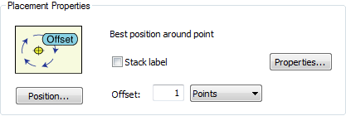
3. Select the Operating-1 Line annotation class.
4. Navigate to Symbol and then Edit Symbol.
5. Select the Advanced Text tab and select Properties under Text Background.  
   
6. Select Symbol on the following screen:  
   
7. Select Edit Symbol.
8. Set the “rounded rectangle” background symbol to match the following image.
9. Delete the “line” symbol in the bottom left box.

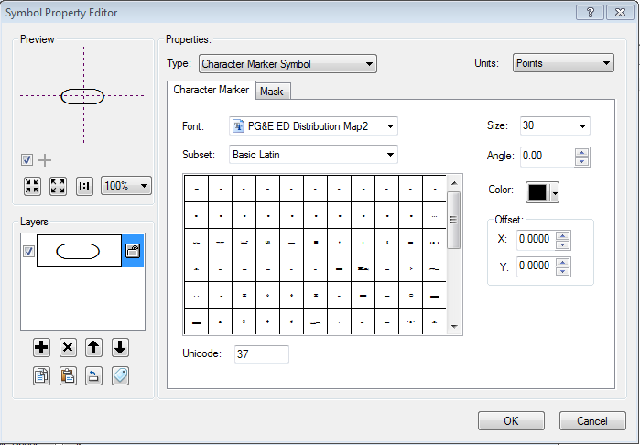

1. Select Symbol->Edit Symbol.
2. Change Operating-1 Line subclass Y offset = 35

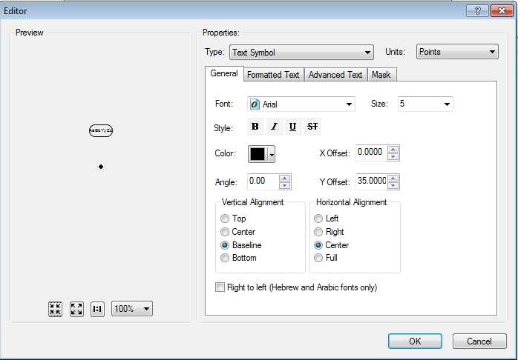

1. Select the Operating-2 Line annotation class.
2. Navigate to Symbol and then Edit Symbol.
3. Select the Advanced Text tab and select Properties under Text Background.  
   
4. Select Symbol on the following screen:  
   
5. Select Edit Symbol.
6. Change Operating-2 Line background symbol as below image:

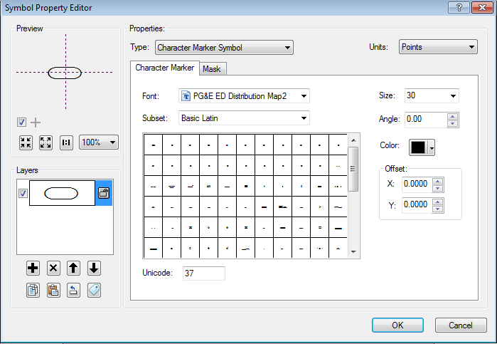

1. Change Operating-2 Line expression to:

Function FindLabel ( [OPERATINGNUMBER], [OPERATINGNUMBER2] )

if len([OPERATINGNUMBER2]) > 0 then

FindLabel = "<UND> " & [OPERATINGNUMBER] & "</UND>" & vbCrLf & [OPERATINGNUMBER2]

end if

End Function

1. Operating-2 Line - Remove “Line” background symbol:  
   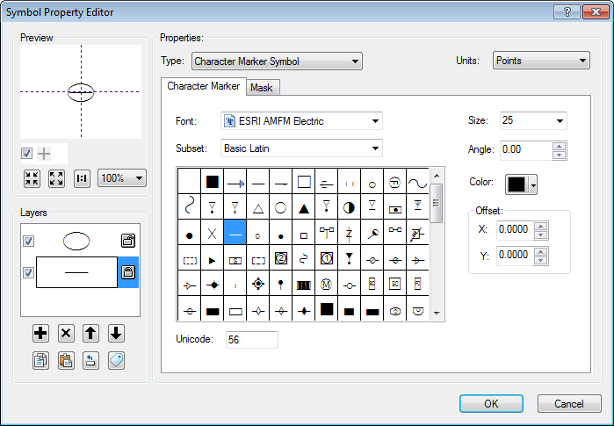
2. Select the symbol on the left and click the X to delete.
3. Select Symbol->Edit Symbol.
4. Change operating-2 Line Y offset = 35

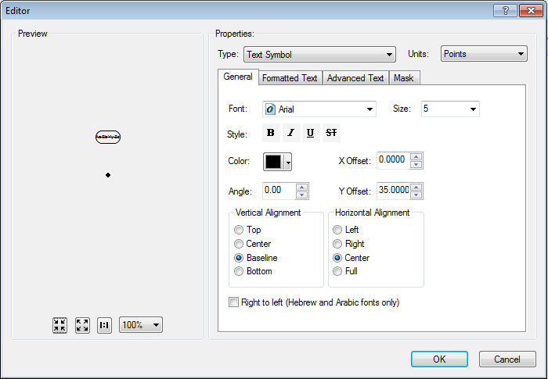

1. Select the Default annotation class and go to Symbol->Edit Symbol.
2. Change Default Y Offset = 5

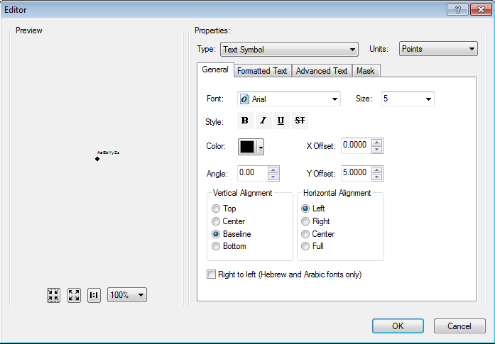

1. Select Expression for the Default annotation class.
2. Change the expression to the following:

Function FindLabel ([LABELTEXT], [HIGHSIDEVOLTAGE], [LOWSIDELNVOLTAGE], [LOWSIDELLVOLTAGE])

  currenttext = ""

  nextline = ""

  myHSVolt = CStr([HIGHSIDEVOLTAGE] & "")

  myLSLLVolt = CStr([LOWSIDELLVOLTAGE] & "")

  myLSLNVolt = CStr([LOWSIDELNVOLTAGE] & "")

  myVolt = ""

  currenttext = [LABELTEXT]

  nextline = ""

  if len(myHSVolt) > 0 then

    if len(currenttext) > 0 then

   currenttext = currenttext & vbCrLf

end if

    currenttext = currenttext & "HV:" & myHSVolt & " KV"

  end if

  if len(myLSLLVolt) > 0 then

    nextline = "LV:" & myLSLLVolt & " V"

      if len(myLSLNVolt) > 0 then

        nextline = nextline & " / "

      end if

  end if

  if len(myLSLNVolt) > 0 then

    nextline = nextline & myLSLNVolt & " V"

  end if

  if len(nextline) > 0 then

    if len(currenttext) > 0 then

   currenttext = currenttext & vbCrLf

end if

    currenttext = currenttext & nextline

  end if

  FindLabel = currenttext

End Function

## SUBSwitchAnno

1. Change all annotation subclasses’ size = 5 (Current, Operating-1 Line, Operating-2 Line)  
   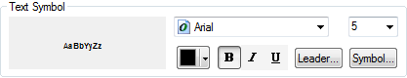
2. Uncheck “Stack Label” on all subclasses (Current, Operating-1 Line, Operating-2 Line)  
   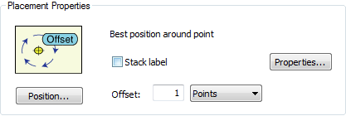
3. Select the Operating-1 Line annotation class.
4. Navigate to Symbol and then Edit Symbol.
5. Select the Advanced Text tab and select Properties under Text Background.  
   
6. Select Symbol on the following screen:  
   
7. Select Edit Symbol.
8. Set the “rounded rectangle” background symbol to match the following image.
9. Delete the “line” symbol in the bottom left box.

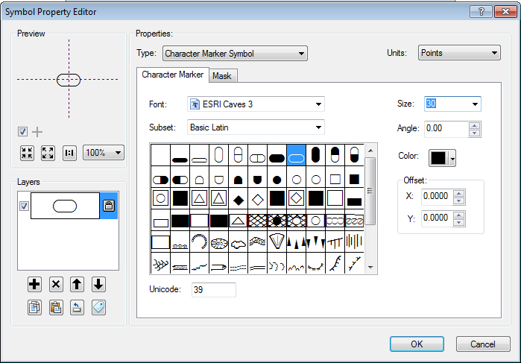

1. Select Symbol->Edit Symbol.
2. Change Operating-1 Line annotation class to Baseline/Center alignment and the Y offset = 25

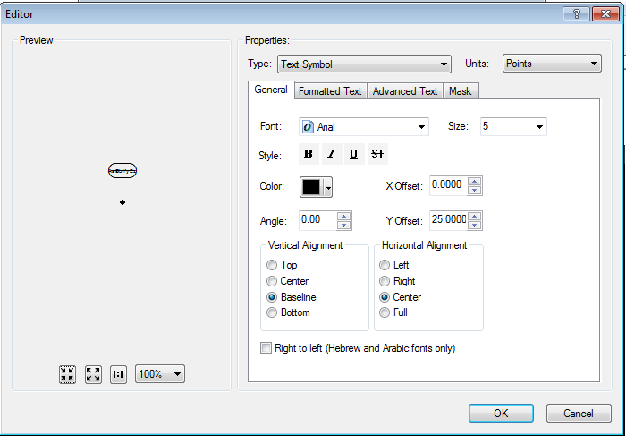

1. Change Operating-1 Line expression to:

Function FindLabel ( [OPERATINGNUMBER], [OPERATINGNUMBER2], [NORMALPOSITION_A], [NORMALPOSITION_B], [NORMALPOSITION_C] )

if isnull([OPERATINGNUMBER2]) and not isnull([OPERATINGNUMBER]) then

if [NORMALPOSITION_A] = "Open" OR [NORMALPOSITION_B] = "Open" OR [NORMALPOSITION_C] = "Open" then

FindLabel = "<CLR green='125'> " & [OPERATINGNUMBER] & " </CLR>"

else

FindLabel = [OPERATINGNUMBER]

end if

end if

End Function

1. Select the Operating-2 Line annotation class.
2. Navigate to Symbol and then Edit Symbol.
3. Select the Advanced Text tab and select Properties under Text Background.  
   
4. Select Symbol on the following screen:  
   
5. Select Edit Symbol.
6. Change Operating-2 Line background symbol to image below:

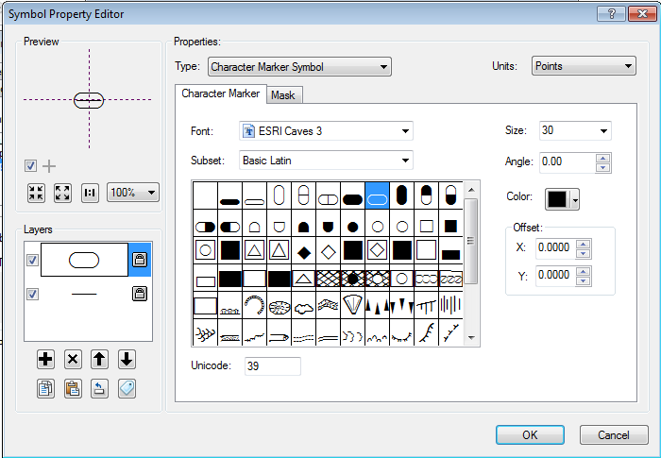

1. Select Symbol->Edit Symbol.
2. Change Operating-2 Line Y offset = 25

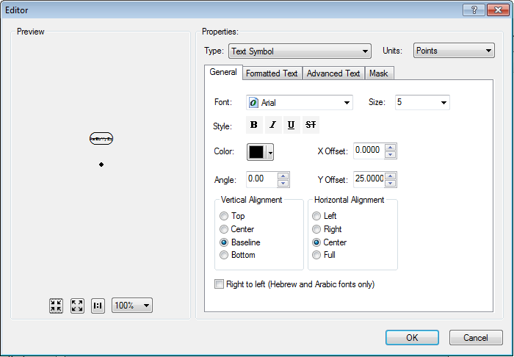

1. Change Operating-2 Line expression to:

Function FindLabel ( [OPERATINGNUMBER], [OPERATINGNUMBER2], [NORMALPOSITION_A], [NORMALPOSITION_B], [NORMALPOSITION_C] )

if not isnull([OPERATINGNUMBER2]) and not isnull([OPERATINGNUMBER]) then

if [NORMALPOSITION_A] = "Open" OR [NORMALPOSITION_B] = "Open" OR [NORMALPOSITION_C] = "Open" then

FindLabel = "<CLR green='125'> " & [OPERATINGNUMBER] & vbcrlf & [OPERATINGNUMBER2] & " </CLR>"

else

FindLabel = [OPERATINGNUMBER] & vbcrlf & [OPERATINGNUMBER2]

end if

end if

End Function

1. Select the Current annotation class.
2. Select Symbol->Edit Symbol.
3. Change Current subclass Y offset = 10

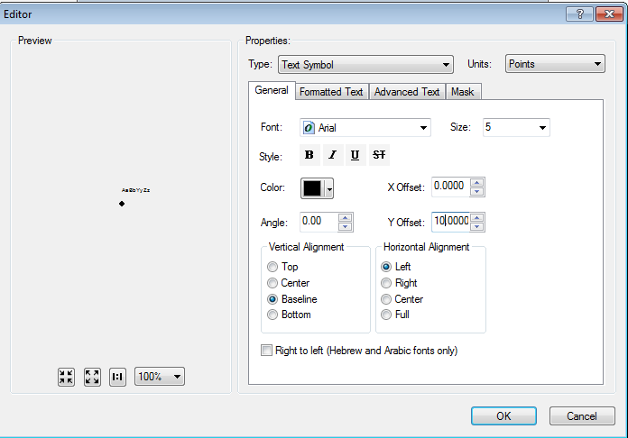

## SUBTransformerBankAnno

1. Select the Default annotation class.
2. Select Symbol->Edit Symbol.
3. Change Default subclass Y offset = 10.

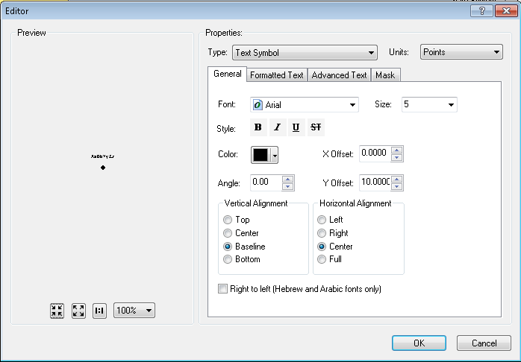

1. Change Default subclass size to 5

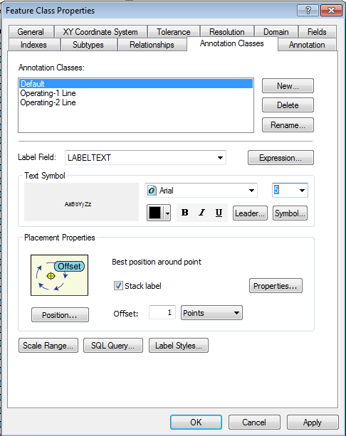

1. Select the Operating-1 Line annotation class.
2. Select Symbol->Edit Symbol.
3. Change the alignment to Baseline/Center and Y Offset = 50.

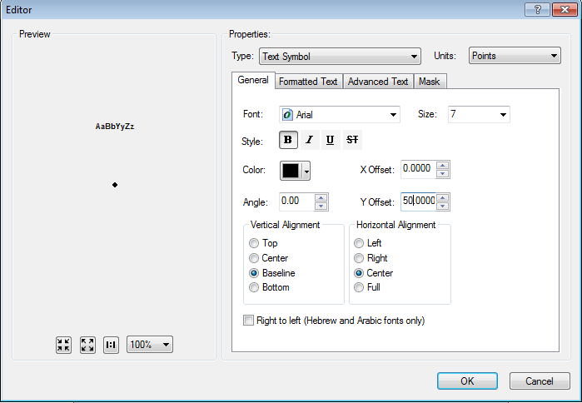

1. Change Operating-1 Line text size = 7 and bold

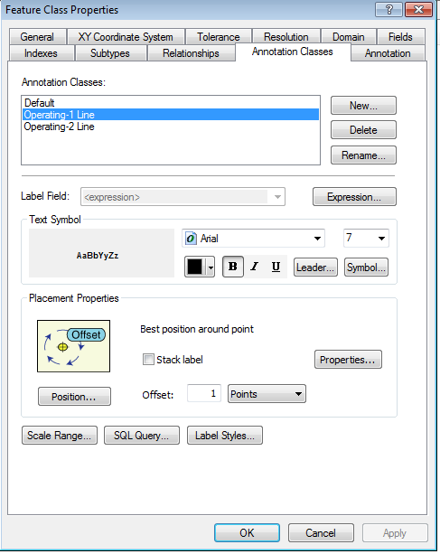

1. Select the Operating-Line 2 annotation class.
2. Select Symbol->Edit Symbol.
3. Change Operating-Line 2 Y offset = 50

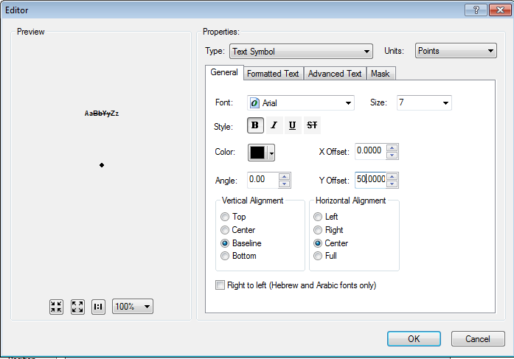

1. Change Operating-2 Line text size = 7 and bold

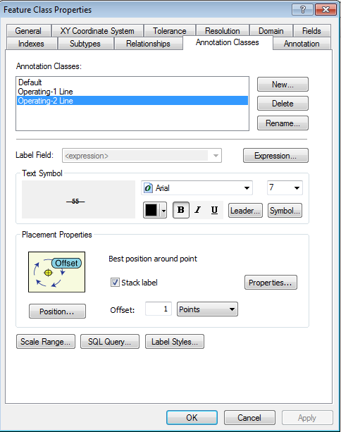

1. Operating-2 Line - Uncheck Stack Label

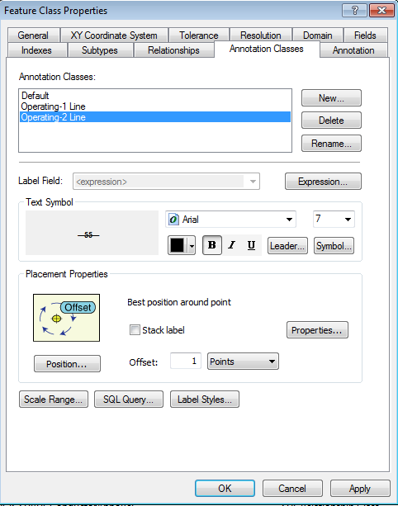

1. Open Symbol->Edit Symbol, select the Advanced Text tab, and uncheck “Text Background”

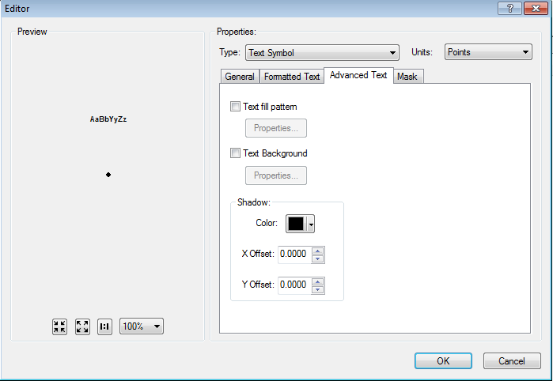

1. Change Operating-2 Line expression to:

Function FindLabel ( [OPERATINGNUMBER], [OPERATINGNUMBER2] )

if len([OPERATINGNUMBER2]) > 0 then

FindLabel = "<UND> " & [OPERATINGNUMBER] & "</UND>" & vbCrLf & [OPERATINGNUMBER2]

end if

End Function

## SUBVoltageRegulatorAnno

1. Select the Default annotation class.
2. Uncheck “Stack label”

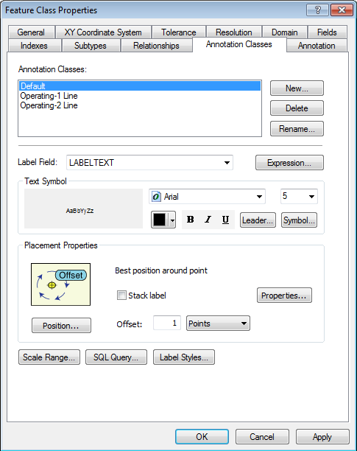

1. Change Default subclass size = 5

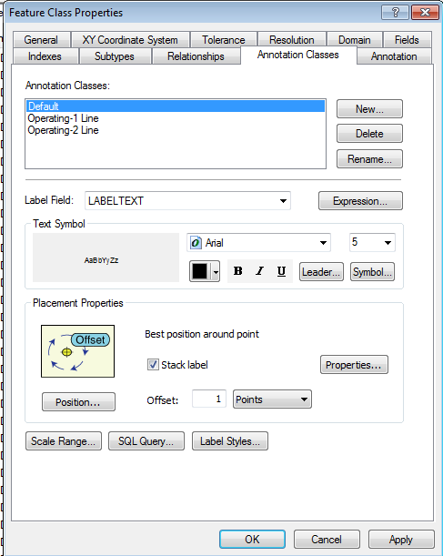

1. Change Default Y offset = 10

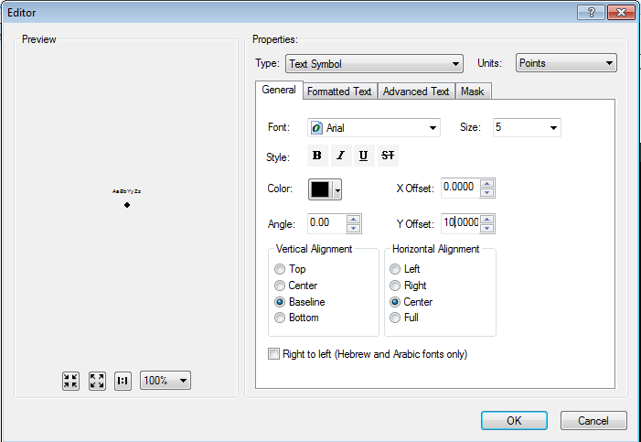

1. Select the Operating-1 Line annotation class.
2. Change Operating-1 Line subclass size = 5 and bold

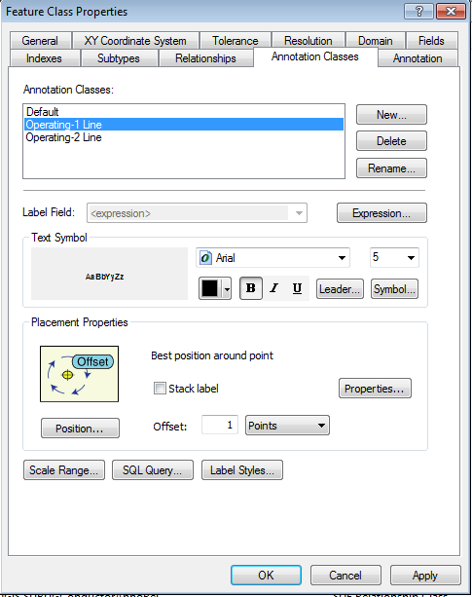

1. Select Symbol->Edit Symbol.
2. Change Operating-1 Line Y offset = 25

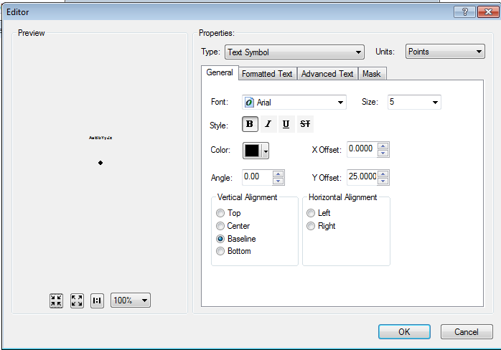

1. Select the Operatng-2 Line annotation class.
2. Change Operating-2 Line size = 5 and bold

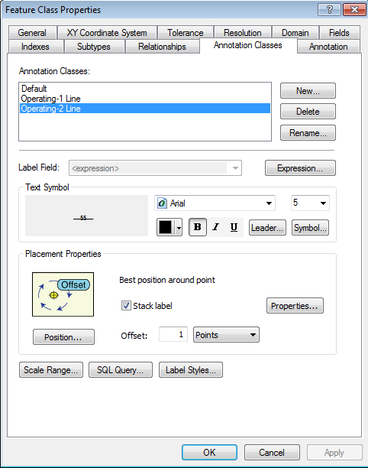

1. Select Symbol->Edit Symbol.
2. Change Operating-2 Line Y offset = 30

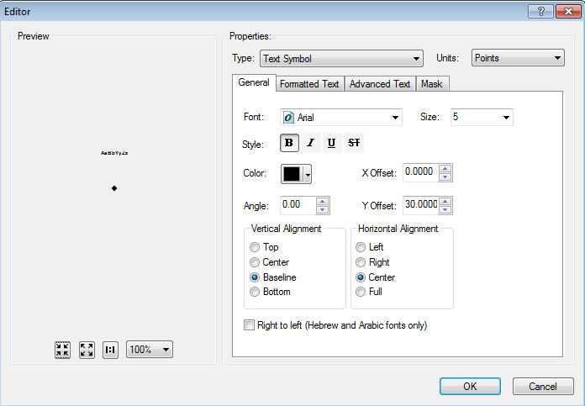

1. Uncheck “Stack Label”

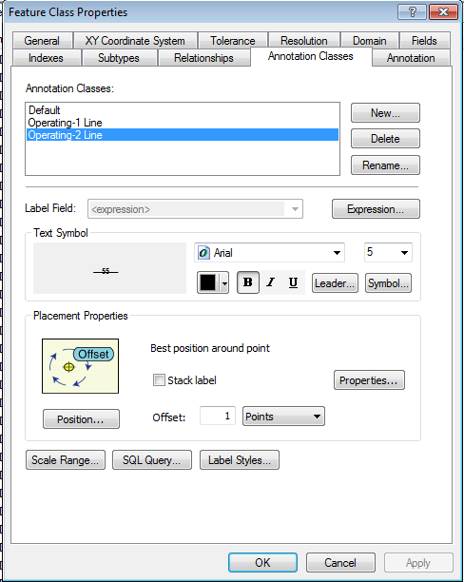

1. Change Operating-2 Line expression to:

Function FindLabel ( [OPERATINGNUMBER], [OPERATINGNUMBER2] )

if len([OPERATINGNUMBER2]) > 0 then

FindLabel = "<UND> " & [OPERATINGNUMBER] & "</UND>" & vbCrLf & [OPERATINGNUMBER2]

end if

End Function

1. Select Symbol->Edit Symbol, click the Advanced Text tab, and Uncheck “Text Background”



## EDGIS.SUBGeneratorAnno

1. Select the Default annotation class.
2. Uncheck “Stack label” and change size to 5

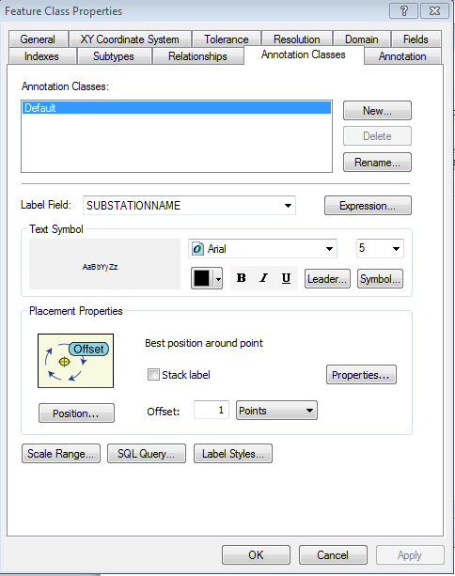

# Remove Carriage Return from field alias SUBStationTransformer for HighSideConfiguration

1. Open the SUBStationTransformer feature class in the SubstationDataset.
2. Select the Fields tab and scroll down to the HighSideConfiguration field.  
   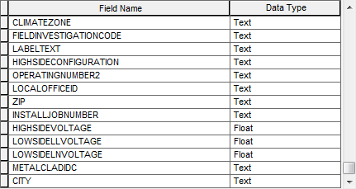
3. Select the HighSideConfiguration field.
4. Select the alias field.  
   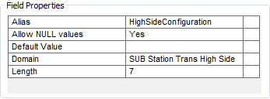
5. Click inside the alias field so that you are editing it.
6. Press End to get to the end of the text.
7. Press Backspace to delete the extra character.
8. This can be validated by closing the Properties, re-opening them, and trying the End again. It should now move to the blank column on the right hand side of the table.

# Remove Carraige Return from field alias SUBMTU for SubmerciblIdc

1. Open the SUBMtu feature class in the SubstationDataset.
2. Select the Fields tab and scroll down to the SubmersibleIdc field.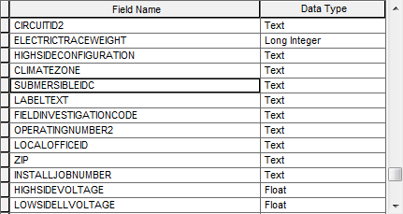
3. Select the SubmersibleIdc field.
4. Select the alias field.  
   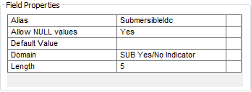
5. Click inside the alias field so that you are editing it.
6. Press End to get to the end of the text.
7. Press Backspace to delete the extra character.
8. This can be validated by closing the Properties, re-opening them, and trying the End again. It should now move to the blank column on the right hand side of the table.

# "SUB Transformer Config" domain addition.

1. Right click the SDE connection and select Properties.  
   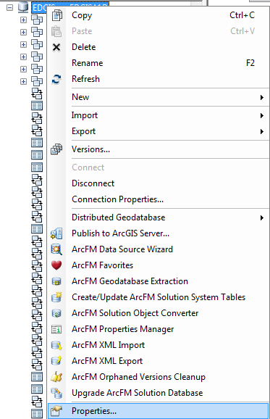
2. In the Domains tab, navigate to the SUB Transformer Config domain and scroll to the bottom in coded values. There should be an empty row at the bottom.  
   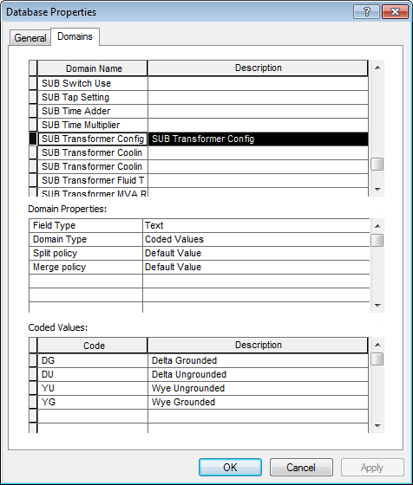
3. Select the Code column in the empty row and add the following value: AT/Auto Transformer. Your screen should look like the following after the change is complete:  
   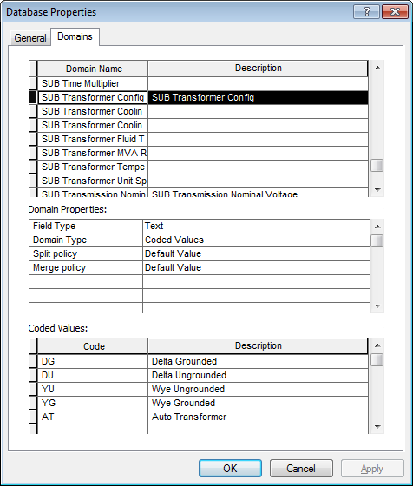
4. Select OK to save changes.

# SUBGeneratorAnno Annotation Expression

1. In the SubstationDataset, right click the SUBGeneratorAnno feature class and select Properties.
2. In the Annotation Classes tab, click Expression.
3. Delete the current expression so that it is blank.  
   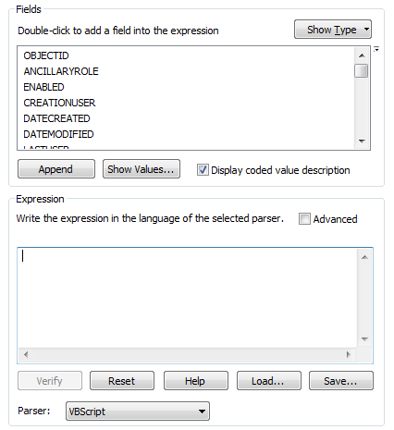
4. Paste in the following expression:

Function FindLabel ([OPERATINGNUMBER],[OPERATINGNUMBER2],[MVARATING],[NOMINALVOLTAGE],[RPM])

myString = ""

  if not isnull([OPERATINGNUMBER]) then  
    myString = myString & [OPERATINGNUMBER]  
  end if

  if not isnull([OPERATINGNUMBER2]) then  
    if not isnull([OPERATINGNUMBER]) then  
      myString = myString & vbCrLf & [OPERATINGNUMBER2]  
    else  
      myString = myString & [OPERATINGNUMBER2]  
    end if  
  end if

  if not isnull(mystring) then  
    if not isnull([MVARATING]) and [MVARATING] <> 0 then  
      myString = myString  & vbCrLf & [MVARATING] & " MVA"  
      if not isnull([NOMINALVOLTAGE]) and [NOMINALVOLTAGE] <> 0 then  
        myString = myString & " " & [NOMINALVOLTAGE] & " KV"  
      end if  
    else  
      if not isnull([NOMINALVOLTAGE]) and [NOMINALVOLTAGE] <> 0 then  
        myString = myString & vbCrLf & [NOMINALVOLTAGE] & " KV"  
      end if  
    end if  
  else  
    if not isnull([MVARATING]) and [MVARATING] <> 0 then  
      myString = myString  & [MVARATING] & " MVA"  
      if not isnull([NOMINALVOLTAGE]) and [NOMINALVOLTAGE] <> 0 then  
        myString = myString & " " & [NOMINALVOLTAGE] & " KV"  
      end if  
    else  
      if not isnull([NOMINALVOLTAGE]) and [NOMINALVOLTAGE] <> 0 then  
        myString = myString & vbCrLf & [NOMINALVOLTAGE] & " KV"  
      end if  
    end if  
  end if

  if not isnull([RPM]) then  
    myString = myString & vbCrLf & [RPM] & " RPM"  
  end if

FindLabel = myString

End Function

1. Select OK and OK again to save changes

# Bug 9829: Delete Relationship Between Conduit System and Subsurface Structure

1. In the Electric Dataset, navigate to the EDGIS.SubsurfStruct_ConduitSystem relationship class.
2. Right click the relationship class and select Delete to delete it.  
   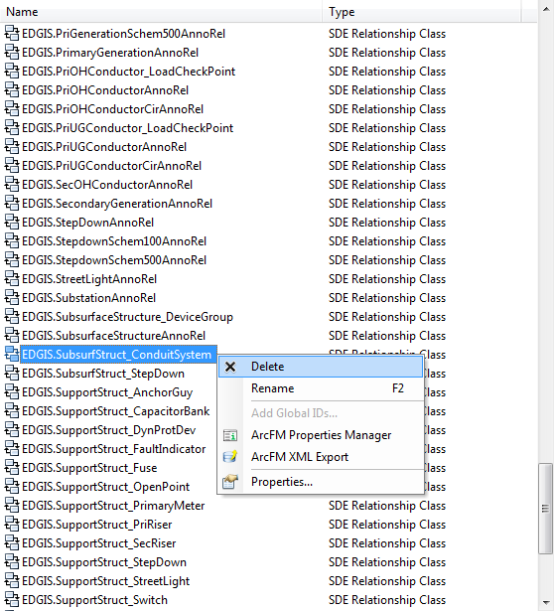
3. Press “Yes” when prompted to confirm deletion.

# Connectivity Rules Update

Import an XML configuration into the database to update connectivity rules

Before performing this step, please ensure that you have the connectivity rules patch (originating from Vinay) installed locally. Without this, performing this step will break the system.

1. Open the Geodatabase Designer toolbar in ArcCatalog.
2. Click the Output Window button on the toolbar to view the Output Window. 
3. Click the XML tab and click Open.  
   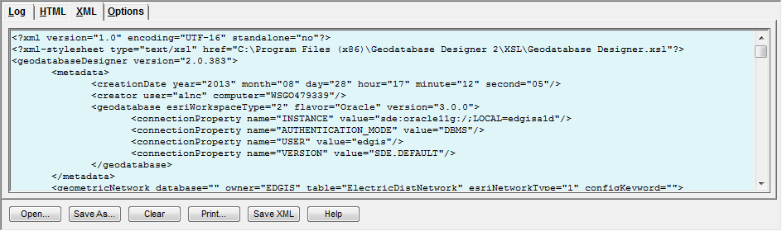
4. Copy/paste the filepath referenced in Section 1.3 of this document (titled External Documents) into the File Explorer window and select the Connectivity file in that folder (name referenced in Section 1.3 of this document).

1. Select the drop down on the toolbar of “Import Schema” ->Import From XML from the Designer toolbar to start the process. The streaming output will appear in the Log tab. When it displays some form of the following sentence, you are done:



# Remove Carraige Return from field alias SUBINTERUPTINGDEVICE for InterruptingMedium and GasGapShuntTripIdc

1. Open the SubInterruptingDevice feature class in the SubstationDataset.
2. Select the Fields tab and scroll down to the InterruptingMedium field.  
   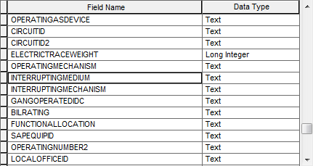
3. Select the field.
4. Select the alias field.  
   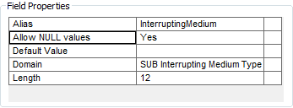
5. Click inside the alias field so that you are editing it.
6. Press End to get to the end of the text.
7. Press Backspace to delete the extra character.
8. This can be validated by closing the Properties, re-opening them, and trying the End again. It should now move to the blank column on the right hand side of the table.
9. Scroll to the GasGapShuntTripIdc field  
   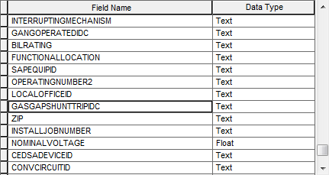
10. Select the GasGapShuntTripIdc field.
11. Select the alias field.  
    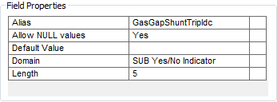
12. Click inside the alias field so that you are editing it.
13. Press End to get to the end of the text.
14. Press Backspace to delete the extra character.
15. This can be validated by closing the Properties, re-opening them, and trying the End again. It should now move to the blank column on the right hand side of the table.

# Substation Generator GlobalID Must Be a GlobalID Type

1. In the SubstationDataset, right click the SUBGenerator feature class and open Properties.
2. Select the GLOBALID field and highlight the row by clicking in the small gray box to the left of the field.  
   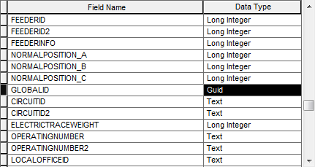
3. Press the Delete key on your keyboard to delete it.
4. Press OK to save changes.
5. Select the feature class and drag it to the root SDE connection to move it outside the SubstationDataset.
6. Right click the feature class and select Add Global IDs.  
   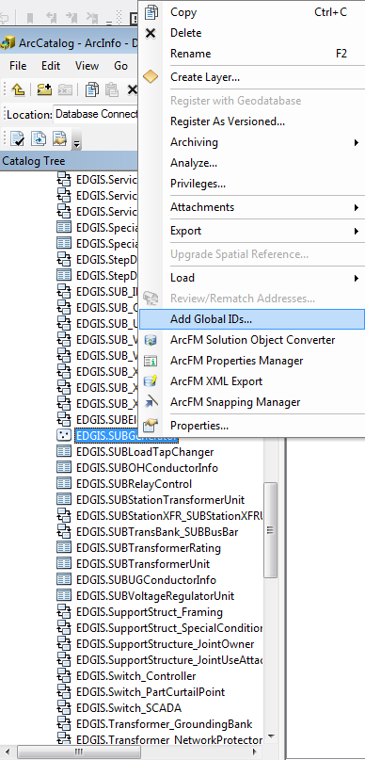
7. Click “Yes”  
   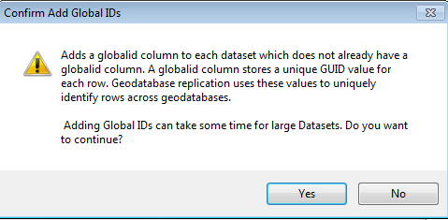
8. Select the feature class and drag it back into the SubstationDataset.

# Update Data Model Version Table

**Database Configuration:**

1. Open SQL Plus.
2. Log in using the same server and user as was used in section 2.  
     
   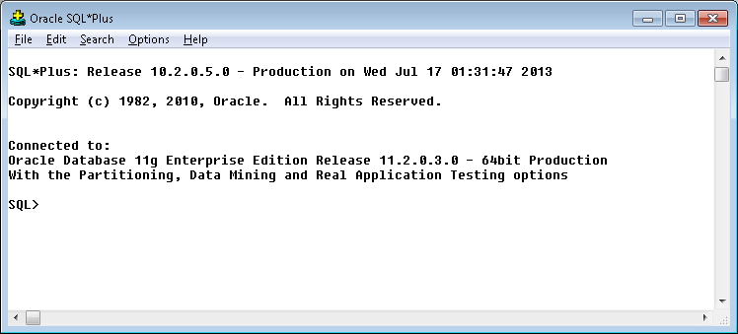
3. Run the SQL below:

update pgedatamodelversion set currentidc='N' where currentidc='Y';

insert into pgedatamodelversion (OBJECTID, CURRENTIDC, DATEAPPLIED, APPLIEDBYPERSONNAME, MODELVERSION) values (**38**,'Y',sysdate,'**Philip Penn**','**7.6.6** GOLD **CR9999**');

commit;

# Known Issues

<Please List any other issues encountered here while following the document>